Week 2: Wireframes and GUI Design

Title

User Interface Planning and System Design

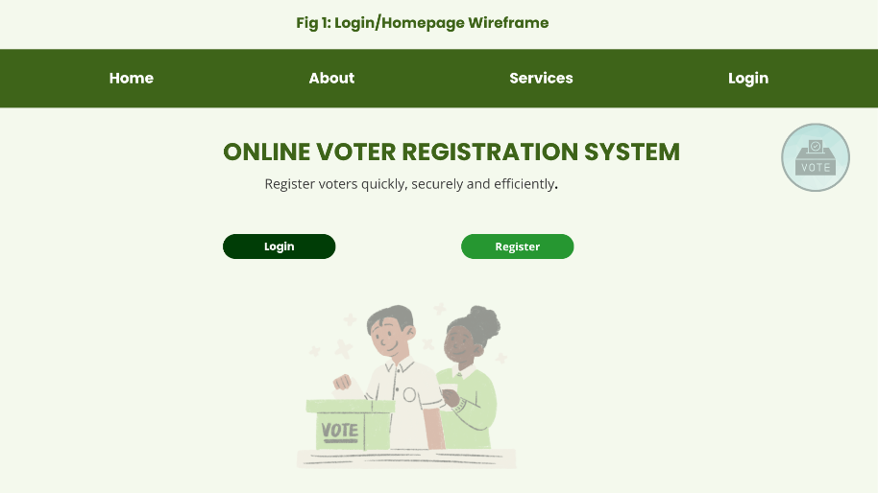
Figure 1: Login/Homepage Wireframe

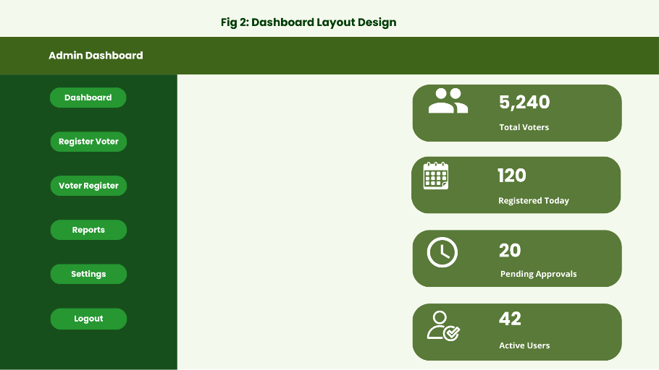
Figure 2: Dashboard Layout Design

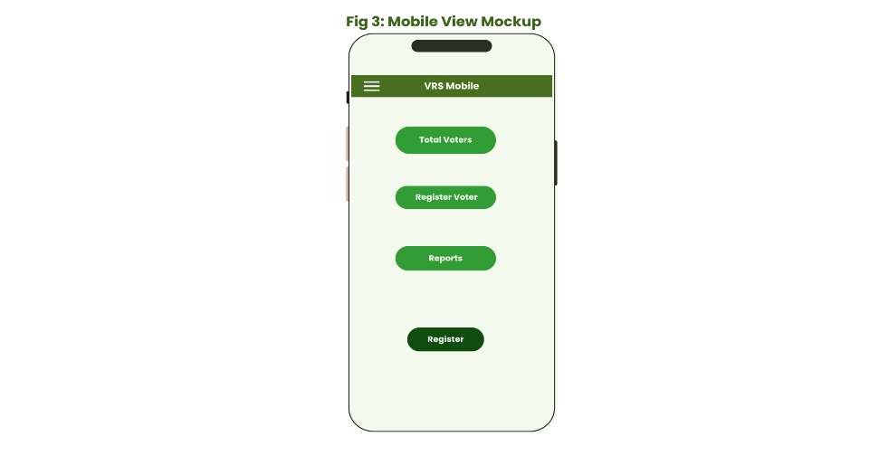
Figure 3: Mobile View Mockup

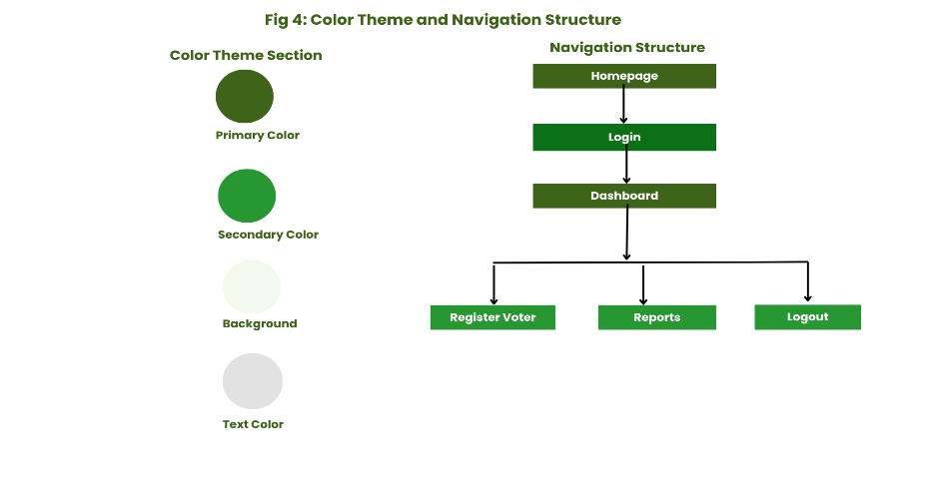
Figure 4: Color Theme and Navigation Structure

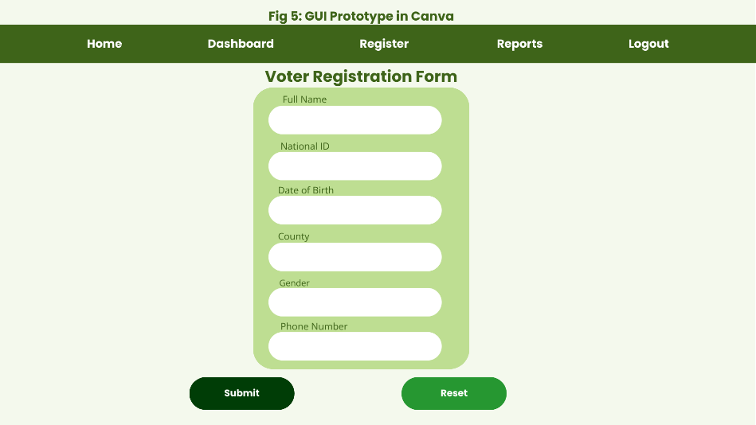
Figure 5: GUI Prototype in Canva

